# 1.查询当前用户下所有的表

select * from user_tab_comments ; 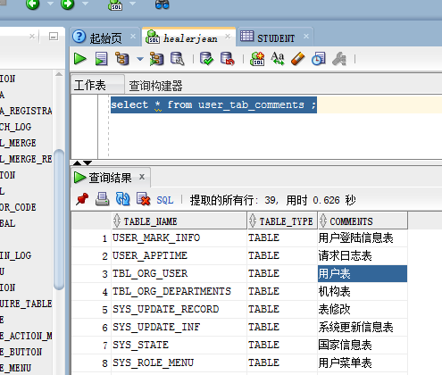

# 2.给表加注释

comment on table TEST_TBL_A is '账户信息';

# 3.给表的字段加注释

comment on column TEST_TBL_A.cif_no is '客户号';

# 4.给表添加主键外键

## 1.主键

**alter table TEST_TBL_C add primary key (mem_no);**

## 2.外键

**alter table TEST_TBL_C add foreign key (group_no) references TEST_TBL_B(group_no);**

# 5. [oracle的级联删除](http://www.cnblogs.com/milo-xie/archive/2011/07/17/2108939.html)

<http://www.cnblogs.com/milo-xie/archive/2011/07/17/2108939.html>

-- Create table

create table CLASS

(

ID VARCHAR2(2) not null,

CLASS_NAME VARCHAR2(20)

)

alter table CLASS add constraint PK_CLASS primary key (ID)

-- Create table

create table STUDENTS

(

ID VARCHAR2(4) not null,

CLASS_ID VARCHAR2(2) not null,

STU_NAME VARCHAR2(20),

STU_AGE NUMBER

)

alter table STUDENTS

add constraint PK_STU primary key (ID)

alter table STUDENTS

add constraint FK_STU foreign key (CLASS_ID)

references CLASS (ID) on delete cascade;

# 6.表空间的创建

create tablespace bqft

datafile 'D:\oracleApp\oradata\orcl\bqft.dbf'

size 100m

autoextend on next 32m maxsize 2048m;

## 6.1解释

stbss 是表空间名称  
D:xxxxx.dbf 是你表空间数据的存放地址和文件名称（oradata的存放路径）  
[size](https://www.baidu.com/s?wd=size&tn=44039180_cpr&fenlei=mv6quAkxTZn0IZRqIHckPjm4nH00T1YLuAc3uyn4rj6vPHR4rycY0ZwV5Hcvrjm3rH6sPfKWUMw85HfYnjn4nH6sgvPsT6KdThsqpZwYTjCEQLGCpyw9Uz4Bmy-bIi4WUvYETgN-TLwGUv3EnWbvn16YnWcv) 100m 开始是100M的大小  
autoextend on next 32m 不够的话会自动增长32M  
maxsize 2048m 最多增加到 2048m